Works and Days – Hesiod

What season is described in the third paragraph?

What does Hesiod suggest?

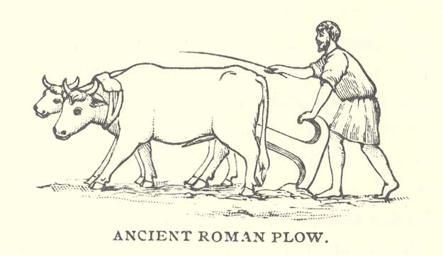

Why should people work hard (paragraph 1)?

What season is described in paragraph 6?

What activity should farmers during this time?

What season is described in paragraph 4?

What activity should farmers do with their ox during this time?

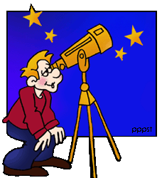

What are Orien and Sirius?

You can now attempt the challenge!