Where is Greece?
What continent is Greece on? _________________________
What are the countries that share borders with Greece?
- To the NW ________________________
Draw the Greek flag in the box below
- To the N __________________________
- To the NNE ________________________
- To the NE/E ________________________

What are the closest countries over sea to the
- West ___________________________
- South West _______________________
- South East ________________________
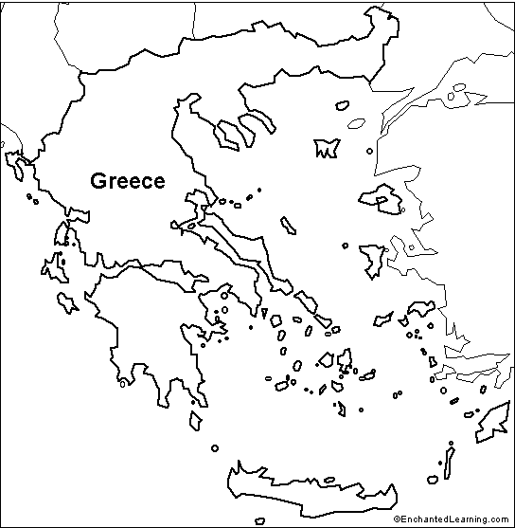
On the map below label
- The countries listed above - draw arrows to the ones not on the map
- Name the seas and bodies of water
- The cities Athens, Heraklion, Thessaloniki, Patras, Ioannina, Prevesa and Katerini

